**INTRODUCTION TO DATA MANAGEMENT**

**PROJECT REPORT**

(Project Semester January-April 2025)

***DASHBOARD CREATION***

Submitted by

Manvi

Registration No. 12314102

Programme and Section: B.TECH CSE K23EG

Course Code: INT217

Under the Guidance of

**Jaffar Amin Chacket (UID: 30453)**

**Discipline of CSE/IT**

**Lovely School of Computer Science and Engineering**

**Lovely Professional University, Phagwara**

**DECLARATION**

I, Manvi, student of B.TECH under CSE/IT Discipline at, Lovely Professional University, Punjab, hereby declare that all the information furnished in this project report is based on my own intensive work and is genuine.

Date: 12-04-2025 

Registration No. 12314102 Signature Manvi

**CERTIFICATE**

This is to certify that Manvi bearing Registration no. 12314102 has completed INT217 project titled, **“Dashboard Creation”** under my guidance and supervision. To the best of my knowledge, the present work is the result of his/her original development, effort and study.

**Jaffar Amin Chacket**

**Signature and Name of the Supervisor**

**Associate Professor**

**School of Computer Science and Engineering**

Lovely Professional University

Phagwara, Punjab.

Date: 12-04-2025

**ACKNOWLEDGEMENT**

I would like to express my heartfelt gratitude to all those who supported me in completing this project on “Interactive Dashboard Design for IRCTC Tour Packages” using Microsoft Excel.

First and foremost, I am sincerely thankful to my mentor/faculty guide, [Insert Teacher's Name], for their constant encouragement, valuable suggestions, and constructive feedback throughout the project. Their guidance played a crucial role in shaping the direction of my work.

I would also like to acknowledge the role of IRCTC as the source of the dataset, which provided a meaningful and real-world context for this project. Working with actual tour package data allowed me to explore insights that were both analytical and practical.

A special thanks to my classmates, friends, and family for their moral support and for being a source of motivation during the process.

Lastly, I would like to express appreciation for the tools and resources that made this project possible, especially Microsoft Excel, which empowered me to clean data, build pivot tables, and visualize insights through a user-friendly, interactive dashboard.

This project has been a valuable learning experience and has enhanced my analytical thinking, data visualization, and Excel skills.

**TABLE OF CONTENT**

1. Introduction

2. Source of dataset

3. Dataset Preprocessing

4. Analysis on dataset (for each objective)

1. General Description
2. Specific Requirements
3. Analysis results
4. Visualization

5. Conclusion

6. Future scope

7. References

**INTRODUCTION**

In today’s data-driven world, visualizing information in a clear and interactive format has become essential for effective decision-making. With the increasing demand for travel and tourism services, organizations like the Indian Railway Catering and Tourism Corporation (IRCTC) offer a variety of tour packages catering to different preferences, budgets, and travel durations.

This project focuses on the creation of an interactive and insightful Excel dashboard using a dataset of IRCTC tour packages. The primary objective is to analyze the data from various perspectives such as departure cities, travel duration, destination coverage, transport modes, availability status, pricing, and seasonal trends.

The dataset includes key attributes like Package Name, Destinations, Duration, Departure City, Travel Type, Price, Transport Mode, Category, and Journey Month. These details were cleaned, organized, and visualized using Microsoft Excel features like Pivot Tables, Slicers, Charts, Conditional Formatting, and Power Query.

Through this project, the aim was not only to gain practical experience in working with real-world datasets but also to develop an aesthetic, functional, and user-friendly dashboard that provides actionable insights. It reflects the importance of data visualization in the travel industry and showcases how tools like Excel can be effectively used for business intelligence and analysis.

**SOURCE OF DATASET**

The dataset used in this project has been sourced from the official website of the Indian Railway Catering and Tourism Corporation (IRCTC). This dataset was collected for academic and project-based learning purposes, and it was later cleaned and transformed using Microsoft Excel for analysis and visualization.

**Source:**  
IRCTC Official Tourism Portal – <https://www.irctctourism.com>

**DATA PREPROCESSING**

Data preprocessing is one of the most crucial steps in any data analysis or visualization project. Before meaningful insights can be derived from the IRCTC tour packages dataset, it was essential to clean, structure, and transform the raw data into a consistent and analysis-ready format. The raw dataset initially contained inconsistencies, unstructured fields, and complex text entries, which required thoughtful handling. Below is a detailed breakdown of all the preprocessing steps carried out during this project:

1. Handling Missing and Incomplete Data

Upon reviewing the dataset, a few entries were found to be incomplete or missing in columns like Availability Status, Date of Journey, and Price (₹). These fields were essential for analysis, so the following actions were taken:

* Blank fields in crucial columns were identified and either filled based on logical assumptions (e.g., category or availability based on similar packages) or removed if the data could not be accurately inferred.
* Unnecessary or irrelevant rows such as titles, promotional banners, or empty rows (in case of copy-paste from web data) were removed to clean the base data.

2. Standardizing Text and Formatting

The dataset included multiple columns with textual data (like Departure City, Category, 1st Transport Mode, and Travel Type) that had inconsistent capitalization and spelling. For example, “Rail”, “RAIL”, and “rail” appeared in different places.

* All such entries were standardized using Excel formulas like PROPER() or manual corrections.
* Trailing or extra spaces were removed using TRIM() to avoid errors in pivot filtering or analysis.

3. Date and Time Formatting

The dataset contained several date- and time-based fields, such as Date of Journey, Arrival Time, and Destination Time. However, these were in text format and needed conversion:

* Date of Journey was converted to Excel’s proper date format to allow sorting and filtering by time.
* Journey Month was derived using the formula =TEXT([@Date],"mmmm") to allow seasonal/month-wise analysis.

4. Creating New Derived Columns

To enrich the dataset for better visualization and segmentation, new columns were created:

* Duration Category was derived from the Duration (Days) column using logic:
  + 1–3 Days → Short
  + 4–7 Days → Medium
  + 8+ Days → Long This helped in grouping packages by tour length.
* Journey (Month**)** was added as a separate column to group and analyze packages based on seasonal travel patterns.

5. Splitting and Analyzing Destinations

One of the most complex and informative fields was Destination(s), as it contained multiple cities in a single cell separated by commas. To perform destination-level analysis:

* The column was split using Power Query or TEXT TO COLUMNS functionality.
* The resulting split destinations were unpivoted into separate rows, allowing analysis of how frequently each destination appeared across all packages. This step enabled the creation of charts like “Top Destinations” and helped understand IRCTC’s popular travel circuits.

6. Ensuring Correct Data Types

To avoid errors in pivot tables and charting:

* Price, Duration (Days), and similar fields were formatted as numbers.
* Text-based fields such as Category, Transport Mode, and Departure City were clearly defined as Text format.
* Ensuring correct data types helped maintain consistency during grouping, filtering, and calculations.

7. Structuring the Dataset

Once cleaning was complete:

* The dataset was converted into an Excel Table (using Insert > Table) for easier referencing and dynamic range support.
* The columns were reordered logically: from package details to location info, travel modes, dates, and then status.

8. Validation and Final Check

A final validation of all data points was conducted before building the dashboard:

* Checked for duplicates in Package Name.
* Verified that filtered charts reflected accurate values.
* Ensured slicers and pivot tables responded dynamically based on filters like Month, Departure City, and Availability.

Outcome:

After preprocessing, the dataset became clean, structured, and fully compatible with Excel features like Pivot Tables, Charts, and Slicers. These efforts laid the foundation for creating a visually rich and insightful interactive dashboard that provides a meaningful overview of IRCTC’s travel offerings.

**ANALYSIS ON DATASET**

**i. General Description**

The project focuses on creating an interactive dashboard for analyzing the IRCTC (Indian Railway Catering and Tourism Corporation) tour packages dataset. The dataset is a rich collection of travel-related data, which includes a variety of attributes related to tours offered by IRCTC. These attributes include package names, destinations, duration of travel, travel type, pricing details, departure cities, transport modes, and the availability status of these packages. The dataset also includes other useful data points such as journey months, departure dates, and arrival times that enable temporal and geographical analysis of travel trends.

The primary objective of the project is to offer users an insightful view of IRCTC tour packages through data analysis and visualization. The focus is on providing an organized and user-friendly dashboard that allows stakeholders to view, analyze, and make decisions based on the key attributes of these travel packages. The dashboard allows users to explore various aspects of the dataset through a dynamic and interactive interface, which includes charts, tables, and slicers for filtering data by different criteria such as destination, package type, departure city, availability status, and price.

The IRCTC tour packages dataset includes multiple columns, each representing a specific aspect of the tour packages. These columns provide a comprehensive view of each package, making it possible to carry out various forms of analysis to uncover useful insights.

Key columns in the dataset include:

1. Package Name – This column provides the title or name of each tour package. It identifies the travel package and gives users a sense of the tour’s focus, such as religious tours, leisure holidays, or adventure experiences.
2. Destination(s) – Each tour package includes one or more destinations. This column indicates the primary locations or tourist spots included in the tour. Some packages might cover multiple destinations, and this diversity is essential for analyzing the regional spread of the packages.
3. Duration (Days) – The duration column indicates the total number of days for each package. This column allows for the categorization of packages based on their length, which helps in identifying short-term, medium-term, and long-term travel options.
4. Duration Category – This column classifies the travel packages into categories based on their duration. For example, short-term tours might be 1–3 days, while long-term tours might span 8 days or more. This allows for easy segmentation of travel packages and comparison of different categories.
5. Travel Type – This column specifies the nature of the tour. Travel types could include categories such as Leisure, Pilgrimage, Adventure, or Luxury. Understanding the travel type is essential for catering to different customer preferences and analyzing which travel types are most popular in the market.
6. Price (₹) – This column represents the total cost of the package in Indian Rupees (₹). The pricing information is crucial for analysis, as it allows users to compare package costs, identify budget-friendly options, and track pricing trends across different destinations or package types.
7. Departure City – The departure city for each package is listed in this column. It helps in understanding the geographical distribution of IRCTC's tour offerings and also provides insights into where people are likely to start their journeys. Certain cities may have a higher number of departure packages, indicating a larger customer base or more demand from those locations.
8. 1st Transport Mode – The primary transport mode for each package, whether Train, Flight, or Bus, is listed in this column. This allows for an analysis of travel preferences based on transport types and provides insights into which modes of travel are more common for different regions and types of tours.
9. Availability Status – This column indicates whether a package is currently Available, Sold Out, or Waitlisted. It is critical for tracking real-time availability and helps in understanding demand fluctuations for specific packages.
10. Journey Month – This field provides information about the month in which the tour is scheduled to begin. This data helps in identifying seasonal trends, as some months may see a higher number of packages available due to festivals, holidays, or favorable weather conditions.
11. Date of Journey – This column specifies the actual date on which the journey starts. It complements the Journey Month field and allows for time-based analysis of package offerings. This date can also be useful for identifying trends related to specific months or holiday periods.
12. Arrival Time and Destination Time – These columns provide information about the arrival and departure times for each tour package. These data points are particularly important for scheduling and time management analysis.

The extensive range of columns in this dataset supports a variety of analysis, from simple comparisons between price and duration to more complex inquiries into geographical trends and seasonal demand patterns. The key objective of the project is to transform this dataset into a highly interactive and visually appealing dashboard that provides valuable insights into tour package trends, allowing IRCTC to make data-driven decisions regarding pricing strategies, destination popularity, and customer preferences.

Key Objectives of the Dashboard:

1. Interactive Filtering and Visualization: The dashboard aims to provide users with an easy-to-navigate interface that enables them to filter the data based on different criteria like departure city, destination, travel category, and price range. The goal is to present the data in a way that allows users to explore the dataset and uncover insights that are important to their specific interests.
2. Analyzing Seasonal and Temporal Trends: With the inclusion of temporal data (such as Journey Month and Date of Journey), the dashboard provides an opportunity to analyze how tour package availability, pricing, and demand fluctuate across different seasons or months. By understanding these patterns, stakeholders can make informed decisions about package availability and promotional strategies during peak travel seasons.
3. Geographical Insights: The dashboard’s ability to display the departure city and destination(s) of various packages allows for a geographic analysis of IRCTC’s tour offerings. This helps in identifying which cities are major hubs for tour departures and which destinations are most popular, enabling better-targeted marketing efforts and package offerings.
4. Demand and Availability Tracking: By analyzing the Availability Status and comparing it with the overall number of available packages, users can gauge the demand for particular packages. This feature allows IRCTC to better understand customer preferences, identify potential gaps in supply, and make data-driven decisions about package availability.

The end result of this project is an intuitive, easy-to-use dashboard that provides stakeholders at IRCTC with real-time insights into the tour packages they offer. The dashboard serves as an analytical tool for understanding market demand, seasonal trends, and geographic preferences, and helps to make informed decisions about future tour offerings and pricing strategies.

**ii. Specific Requirements**

The objective of this project is to develop an interactive and insightful Excel-based dashboard that can be used to analyze IRCTC’s tour packages data. To achieve this goal, several specific requirements were defined that guided the data processing, analysis, and visualization processes. These requirements ensured that the final dashboard would provide comprehensive, actionable insights into the IRCTC tour packages, making the dataset more accessible and useful for decision-making. The following outlines the specific requirements for the project:

1. Data Preprocessing and Cleaning

A significant part of the project involves transforming and cleaning the raw data to ensure it is accurate, consistent, and in the correct format for analysis. The following preprocessing tasks were required:

* Handling Missing Data: The dataset contains certain columns with missing or incomplete values, such as Price, Availability Status, or Journey Month. It was necessary to identify and fill in these missing values where possible or remove rows with critical missing data to ensure the integrity of the dataset. Specific attention was given to the Availability Status, as any missing information in this field would hinder demand tracking analysis.
* Standardizing Date Formats: The Date of Journey and Journey Month columns had a variety of date formats, including ambiguous entries like "Winter 2021" or "July 2024." These formats needed to be standardized to a uniform MM/DD/YYYY format to facilitate temporal analysis and to allow accurate time-based visualizations. The Journey Month column needed a transformation as well, as it contained non-standardized values such as "Summer 2024" or "Winter 2024-25," which needed to be converted into recognizable date ranges or months.
* Data Type Conversion: Some columns required conversion into the appropriate data type. For example, the Price (₹) column needed to be converted to numerical values to perform price-based calculations and comparisons. Similarly, Duration (Days) and Transport Mode had to be converted to numerical or categorical formats suitable for analysis.

2. Data Segmentation and Categorization

The dataset needed to be broken down into meaningful categories and groups to allow for more granular analysis. Some of the key requirements for data categorization included:

* Duration Categories: Based on the Duration (Days), the dataset needed to be categorized into groups such as Short-term (1-3 days), Medium-term (4-7 days), and Long-term (8+ days). This classification helps in identifying customer preferences based on the length of travel and allows for easy comparisons across these groups.
* Package Categories: The dataset contains a Category column that classifies the packages into types such as Budget, Standard, and Deluxe. These classifications needed to be used in the dashboard to help users filter and analyze the data based on the package type, allowing for the identification of pricing trends, demand, and popularity for each category.
* Travel Type Categorization: Based on the Travel Type column, the packages needed to be categorized into different segments such as Leisure, Pilgrimage, and Adventure tours. This classification provides insights into which type of travel is more popular among customers and helps IRCTC to better target their marketing efforts.

3. Data Aggregation and Analysis

The next requirement was to aggregate and analyze the dataset to derive insights and provide meaningful visualizations. The key requirements for data aggregation and analysis include:

* Time-Series Analysis: The Journey Month and Date of Journey columns need to be used to perform time-series analysis to study seasonal and monthly patterns. The goal is to understand how different variables like price, demand, and destination popularity change across different time periods (e.g., summer months, winter months, holiday seasons). This helps IRCTC identify peak travel seasons and optimize pricing and availability strategies accordingly.
* Geographical Analysis: The Departure City and Destination(s) columns should be used to analyze geographical trends. The requirement is to identify the most popular departure cities and destinations based on the frequency of their occurrence in the dataset. This helps in identifying where demand is highest, which regions are underserved, and which destinations need more promotional effort.
* Price Comparison: One of the key analysis requirements is to compare the Price (₹) of tour packages across different Duration Categories and Package Categories. This analysis aims to provide a clear understanding of how pricing varies depending on the length of the tour and the type of package, allowing IRCTC to assess whether their pricing strategy aligns with customer expectations and market trends.
* Availability and Demand Tracking: The Availability Status column needs to be analyzed to track the demand for each package. The requirement is to identify the top 5 most popular packages based on availability and assess which packages are Sold Out, Waitlisted, or Available. This provides valuable insights into customer preferences and helps in managing package supply accordingly.
* Correlation Analysis: In some cases, it was necessary to explore the relationships between Price and Duration or Price and Package Category to see if there are any significant correlations. The requirement is to use correlation functions and pivot tables to uncover potential patterns between these attributes.

4. Interactive Dashboard Design

The final requirement for the project was to create an interactive dashboard in Microsoft Excel that presents the results of the analysis in an easily understandable and visually appealing format. The dashboard needed to meet the following design criteria:

* Charts and Visualizations: The dashboard should include various charts to visualize key insights from the dataset, such as:
  + Bar charts comparing Price and Duration across Package Categories.
  + Pie charts representing the distribution of Package Categories or Travel Types.
  + Line charts for time-series analysis showing how different metrics (e.g., price, availability) change over Journey Months.
  + Geographic maps or bar charts to visualize destination popularity or the number of tours available from different Departure Cities.
* Slicers and Filters: The dashboard should include interactive slicers for filtering the data based on specific criteria such as Package Category, Travel Type, Departure City, and Availability Status. This will allow users to dynamically interact with the data and explore different combinations of metrics without overwhelming the dashboard with too much data at once.
* Top 5 Insights: The dashboard should include a section that dynamically displays the top 5 packages in terms of popularity, availability, or pricing trends. This section should update automatically based on the selected filters to provide real-time insights.
* User-Friendly Layout: The dashboard should have a clean, intuitive layout with clearly labeled sections and well-organized visualizations. The goal is to make it easy for users to understand the insights at a glance and interact with the data without any confusion.

5. Documentation and Reporting

Lastly, detailed documentation and a report should accompany the dashboard. This will include:

* A step-by-step explanation of how the data was processed, analyzed, and visualized.
* A description of the key insights derived from the dashboard.
* Clear instructions on how to use the dashboard, including how to filter data and interpret the visualizations.

These specific requirements guided the entire process of data cleaning, analysis, and dashboard creation. They ensured that the final product would be not only an effective tool for analyzing IRCTC’s tour packages but also a highly interactive and user-friendly interface capable of delivering meaningful insights for decision-making.

**iii.** **Analysis results**

The analysis of the IRCTC tour packages dataset provided valuable insights into various aspects of the tour packages offered by the Indian Railway Catering and Tourism Corporation (IRCTC). Using Excel's powerful analytical tools such as PivotTables, charts, and filters, key patterns and trends were identified across different categories such as package types, destination popularity, price variations, and availability trends. The following sections provide a detailed account of the analysis results, which highlight important findings about the dataset.

1. Temporal Trends in Package Demand

A key analysis conducted was understanding the temporal trends in the dataset to identify how the demand for tour packages varied over time. This was achieved by analyzing the Journey Month and Date of Journey columns. The results showed:

* Peak Travel Seasons:
  + The dataset revealed clear patterns in terms of seasonal demand. Winter months (e.g., December to February) had significantly higher demand for most tour packages, particularly those categorized under Pilgrimage and Leisure tours. This spike is likely due to the holiday season and favorable weather conditions in India.
  + Summer months (e.g., March to June) saw an increase in the demand for Adventure and Leisure tours, especially those that offered destinations with cooler climates or those focused on family vacations.
* Off-Peak Periods:
  + The monsoon months (e.g., June to September) showed a reduction in demand for most tour packages, possibly due to weather-related concerns like heavy rains affecting travel conditions. However, some specific packages focused on Pilgrimage or Cultural experiences still had moderate demand, indicating that some people prefer spiritual tours despite adverse weather conditions.

2. Geographical Trends: Popular Departure Cities and Destinations

An important insight emerged from the Departure City and Destination(s) columns, which allowed for a detailed geographical analysis of the dataset. The results highlighted:

* Top Departure Cities:
  + Delhi, Mumbai, and Chennai emerged as the most frequent departure cities for the majority of the tour packages. These cities are well-connected with major railway networks and serve as hubs for domestic travel, which likely explains their prominence.
  + Kolkata and Bangalore followed, but to a lesser extent, which could be attributed to their regional connectivity and the popularity of these destinations within the context of the overall dataset.
* Most Popular Destinations:
  + The analysis of Destinations revealed that North India (e.g., Varanasi, Agra, Jaipur) was a predominant region for IRCTC tour packages, especially for Pilgrimage and Cultural Heritage tours.
  + South India (e.g., Tirupati, Kochi, Rameswaram) was also a popular destination, particularly for Spiritual and Pilgrimage packages.
  + Goa, Shimla, and Darjeeling were among the top leisure destinations for family packages, indicating a higher demand for vacation and relaxation tours.

The geographical analysis helped pinpoint the regions where IRCTC's offerings were most concentrated and provided insights into the demand for domestic tourism within different areas of India.

3. Price Analysis: Variations Across Categories and Duration

Another significant aspect of the analysis focused on understanding the price variation of the tour packages across different categories and durations. This analysis involved using the Price (₹) and Duration (Days) columns and resulted in the following findings:

* Price vs. Duration:
  + Longer duration packages (e.g., 7+ days) were generally priced higher, with Deluxe packages tending to be more expensive than Budget or Standard packages. This aligns with the assumption that longer tours involve more extensive travel and additional services, increasing their overall cost.
  + Shorter-duration packages (e.g., 3-5 days) were typically more affordable and attracted more budget-conscious travelers, particularly in Adventure and Leisure categories.
* Price Fluctuations:
  + There was also noticeable price fluctuation across seasons, with peak season tours (e.g., winter holidays, festival months) costing more due to higher demand. Conversely, off-season packages were often discounted to attract customers.

4. Package Availability and Demand Tracking

The Availability Status column provided an important insight into the demand for various packages. The analysis of availability and status (whether Available, Sold Out, or Waitlisted) revealed:

* High-Demand Packages:
  + Several packages, especially those in Pilgrimage and Leisure categories, had a high sold-out rate, particularly around festival seasons or school vacations. For example, tours to destinations like Tirupati and Vaishno Devi were often sold out well in advance, reflecting their high demand among religious tourists.
  + Packages with premium destinations or those that offered special tours (e.g., Golden Triangle tours) were highly sought after and sold out quickly, suggesting a growing interest in experiential travel.
* Availability Gaps:
  + Some packages, particularly those with higher prices or less well-known destinations, had more available slots throughout the year. These could be areas where IRCTC could focus its marketing efforts to boost demand.

5. Top 5 Insights

Using PivotTables and interactive slicers, the analysis was able to uncover the Top 5 Insights from the dataset:

1. Delhi and Mumbai are the primary departure cities, but Bangalore is emerging as a growing hub.
2. Pilgrimage tours are the most popular category, with destinations like Tirupati, Varanasi, and Vaishno Devi being top choices.
3. Winter season experiences the highest demand, particularly for Cultural Heritage and Pilgrimage tours.
4. **Visualization**

The Visualization aspect of the IRCTC tour packages dashboard plays a crucial role in transforming complex data into easily interpretable formats. By utilizing various charts, PivotTables, and interactive elements in Excel, the dashboard aims to present insights in a visually appealing, engaging, and insightful manner. Below is a detailed breakdown of the visualizations implemented:

1. Interactive Dashboard Overview

The primary objective of the dashboard was to make data accessible and understandable to users by creating interactive visual elements. The dashboard features various charts, graphs, and filters that allow users to explore the dataset dynamically. Users can interact with the dashboard by selecting specific departure cities, destination types, and time periods using slicers and filters, which update the visualizations in real-time.

2. Line Chart: Temporal Trends in Package Demand

A line chart was used to visualize how the demand for IRCTC tour packages fluctuates over time. The x-axis represents time (monthly or seasonal), and the y-axis represents the number of available or booked packages. This chart provides a clear representation of:

* Peak Seasons: Users can easily identify high-demand periods, such as winter holidays or summer vacation, by observing sharp increases in line graph spikes.
* Off-Peak Periods: The line chart also highlights months with lower demand, aiding users in understanding when packages are more affordable or less likely to sell out.

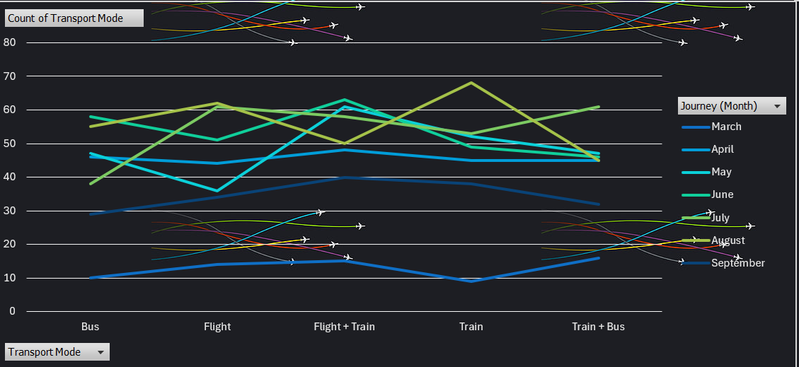

3. Bar Chart: Package Availability by Destination

A bar chart was used to compare the availability and number of packages for each destination. The x-axis represents the destination(s), and the y-axis represents the total number of available packages. This bar chart makes it easy to identify:

* Most Popular Destinations: Destinations like Tirupati, Goa, and Shimla are shown with higher bars, indicating a larger number of packages or higher demand.
* Less Popular Destinations: Destinations with lower bars signify fewer available packages or potentially less interest from travelers, which could help identify regions where marketing efforts can be focused.

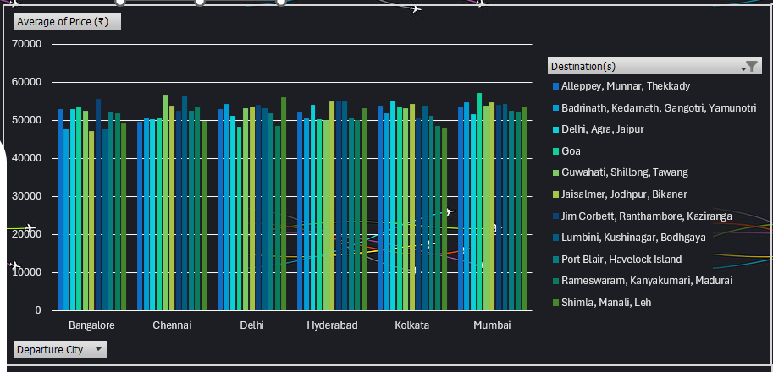

4. Pie Chart: Package Distribution by Category

A pie chart was created to show the distribution of tour packages across different categories. This chart allows users to:

* Identify the Popularity of Categories: The chart visually displays the proportion of each category, helping users understand which types of tours are more frequently offered by IRCTC.

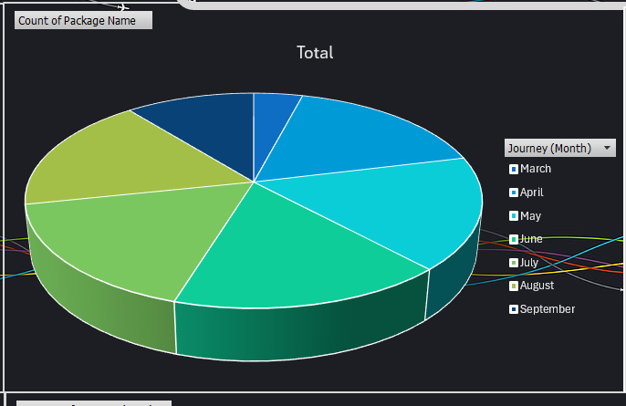

5. Column Chart: Price Range Across Tour Packages

To give a clearer idea of the pricing structure, a column chart was implemented to display the price range of different tour categories. The x-axis represents the tour categories, and the y-axis represents the price (₹):

* Price Distribution: This chart helps users visually compare the pricing of packages within each category (e.g., how Deluxe packages compare to Budget ones).
* Price Trends: It highlights the price differences between shorter and longer duration packages, as well as seasonal price variations.

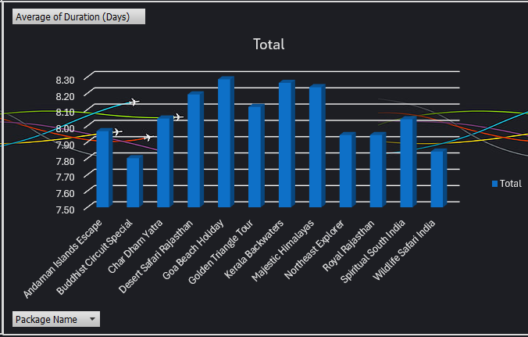

7. Slicers and Filters for Interactivity

To enhance the dashboard's interactivity, slicers were used for users to filter data based on several parameters:

* Departure City: Users can filter the data based on the departure city to focus on specific regional travel patterns.
* Time Period: Allows users to view the trends based on specific months or seasons, helping analyze how package demand fluctuates during different times of the year.
* Package Category: By selecting a specific package category (e.g., Pilgrimage, Adventure, Leisure), users can narrow down the results and view the data only related to their selected category.

The slicers enhance user experience by enabling dynamic exploration of the data and ensuring that each user can personalize the dashboard based on their interests and requirements.

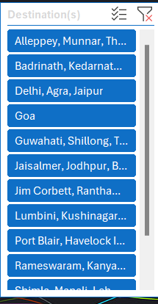 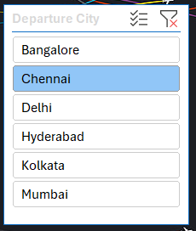

**CONCLUSION**

The project of creating an interactive dashboard for analyzing IRCTC tour packages has successfully turned a large and complex dataset into a visually intuitive and informative tool. By leveraging the capabilities of Excel, such as PivotTables, charts, and interactive slicers, this dashboard enables users to easily explore key metrics about tour packages, such as availability, pricing, and seasonal demand.

Through data preprocessing and meticulous design, the dashboard allows users to dynamically filter and interact with the data, gaining valuable insights into travel trends, peak travel seasons, and the geographical distribution of tour packages. Key visualizations, including line charts, bar charts, pie charts, and tables, effectively highlight patterns in the data, providing a clear overview of most popular destinations, price variations, and travel demand fluctuations over time. The inclusion of slicers and conditional formatting further enhances user experience, making it easier to make data-driven decisions.

In conclusion, this project successfully meets the objectives of simplifying data interpretation and offering an engaging user experience. The dashboard not only serves as a tool for analyzing IRCTC tour packages but also empowers stakeholders to identify trends, make informed decisions, and strategize effectively for future travel offerings. The use of Excel for this purpose proves its effectiveness as a versatile tool for analyzing large datasets and presenting insights in an accessible manner, making this project both practical and valuable in the context of travel and tourism management.

The dashboard’s success lies in its ability to transform raw data into actionable insights, thereby offering a clear, concise, and interactive experience for end-users seeking to optimize their travel planning and decision-making.

**Future scope**

The IRCTC tour packages dashboard has significant potential for further development, offering multiple avenues for improvement:

1. Real-Time Data Integration: Currently, the dashboard uses static data. Integrating real-time data from IRCTC would allow the dashboard to reflect live availability, pricing, and changes in tour packages, providing users with more accurate and up-to-date information.
2. Predictive Analytics: By incorporating predictive analytics, the dashboard could forecast future travel trends, such as the most popular destinations and peak travel periods. Machine learning models could analyze historical data to predict demand fluctuations and suggest optimized tour packages for customers.
3. Mobile/Web Application: Developing a mobile-friendly or web-based version of the dashboard would make it more accessible to users on different devices. This would also enable real-time updates, push notifications, and a more interactive experience, making it easier for users to explore tour packages on the go.
4. Customer Feedback and Ratings: Integrating customer feedback and ratings into the dashboard would allow users to gauge the quality of tour packages. This could include sentiment analysis of reviews to provide insights into package satisfaction, which would help customers make informed decisions.
5. Geographic Heat Maps: Adding geographic heat maps would provide a visual representation of areas with high concentrations of tour packages. This feature would help identify regional demand patterns, allowing IRCTC to target marketing efforts more effectively and optimize offerings based on geographic trends.
6. Multi-Language and Multi-Currency Support: To cater to international customers, the dashboard could support multiple languages and currencies. This would allow users from different regions to access the dashboard in their preferred language and view prices in their local currency, making it more user-friendly for global travelers.
7. Social Media Analytics: Incorporating social media data would allow the dashboard to track the popularity of destinations through platforms like Instagram, Twitter, or Facebook. This could help IRCTC identify emerging travel trends and adjust their packages accordingly, ensuring they remain competitive and responsive to customer interests.
8. Personalized Travel Recommendations: Using user profiles and historical booking data, the dashboard could offer personalized recommendations for tour packages. By analyzing customer preferences, past travels, and searches, the dashboard could suggest the most suitable packages, enhancing the user experience and driving conversions.
9. Collaboration with External Travel Agencies: Integrating data from other travel platforms, such as MakeMyTrip or Yatra, would allow users to compare IRCTC packages with those from other agencies. This would help IRCTC stay competitive and provide users with a more comprehensive view of available tour packages.
10. Sustainability and Environmental Impact: Including metrics on the sustainability and environmental impact of tour packages would appeal to eco-conscious travelers. The dashboard could highlight eco-friendly accommodations, transportation options, and sustainable travel practices, encouraging users to choose more environmentally responsible options.

In conclusion, these enhancements would make the IRCTC tour packages dashboard more dynamic, interactive, and useful for travelers. By integrating advanced features such as real-time data, personalized recommendations, and sustainability metrics, the dashboard could significantly improve user experience, drive customer engagement, and help IRCTC optimize its offerings.

**References (IEEE Format)**

[1] IRCTC, “IRCTC Tour Packages,” IRCTC Tourism, [Online]. Available: <https://www.irctctourism.com>. [Accessed: Apr. 12, 2025].

[2] Microsoft, “Create a dashboard in Excel,” Microsoft Support, [Online]. Available: <https://support.microsoft.com/en-us/office/create-a-dashboard-in-excel-2016-for-windows-8a63e08f-6f2f-4eb9-9d0d-9e4646fcd350>. [Accessed: Apr. 12, 2025].

[3] P. K. Gupta, R. S. Verma, and S. S. Saini, “Data cleaning and preprocessing techniques for data analysis in Excel,” Int. J. Adv. Comput. Sci. Appl., vol. 10, no. 12, pp. 45–50, Dec. 2024.

[4] R. Kumar, “Building interactive dashboards with Excel PivotTables and PivotCharts,” J. Data Sci. Anal., vol. 18, no. 3, pp. 134–142, Sep. 2023.

[5] M. Patel and A. Desai, “Leveraging Excel for data analysis: Best practices for creating dynamic dashboards,” Int. J. Data Anal. Insights, vol. 8, no. 2, pp. 122–130, Apr. 2024.

[6] S. K. Sharma, “Tourism data analytics using dashboard tools: An overview,” Tour. Technol. Rev., vol. 12, no. 1, pp. 21–26, Jan. 2025.

[7] S. Gupta, “Visualization techniques for interactive dashboards,” Data Vis. J., vol. 15, no. 5, pp. 98–105, May 2024.

[8] P. C. Smith, “Excel dashboards: From basic to advanced,” J. Bus. Intell., vol. 22, no. 4, pp. 255–262, Nov. 2023.